Case Study Report

Main Title
  - Subtitle
First name SURNAME, Affiliation, Country
First name SURNAME, Affiliation, Country

Abstract
The abstract should give a brief overview of the article content. It is afterwards published as a manuscript synopsis, so please be careful when writing this short piece of text – the readers might be either encouraged to dig further into the text or deterred by the quality of this short introductory note. Please include the main findings, briefly summarised and preceded by the short introductory note that explains the case study context and significance. It is not recommended to use references in the abstract. It is recommended to include no more than 200 words in this part. Lorem ipsum dolor sit amet, consectetur adipisicing elit, sed do eiusmod tempor incididunt ut labore et dolore magna aliqua. Ut enim ad minim veniam, quis nostrud exercitation ullamco laboris nisi ut aliquip ex ea commodo consequat. Duis aute irure dolor in reprehenderit in voluptate velit esse cillum dolore eu fugiat nulla pariatur. Excepteur sint ocaecat cupidatat non proident, sunt in culpa qui officia deserunt mollit anim id est laborum. Lorem ipsum dolor sit amet, consectetur adipisicing elit, sed do eiusmod tempor incididunt ut labore. Lorem ipsum dolor sit amet, consectetur adipisicing elit, sed do eiusmod tempor incididunt ut labore.

Keywords
Keyword, Keyword, Keyword, Keyword (3 to 6 keywords)

1. Heading

1.1. Subheading
Case study report is a professional contribution to the planning practice focused on elucidating a specific project, proposal, plan, design, existing or work-in-progress development, etc.

Case study report counts between 2000 and 3000 words, including the manuscript and references. The text should be accompanied by tables and figures for the clarity of presentation. It might also contain photographs presenting a case study context. When applicable, please add acknowledgements and information about the research funding.

The manuscript should have an explicit focus and a clear organisation. We suggest the following structure:
- The starting problem addressed by the project
- Explanation of the context (socio-political, economic, etc.) the project is embedded within
- The project approach (e.g., multidisciplinary; PPP; step-by-step approach, etc.)
- The results of the project
- Broader project impact

It is the authors' responsibility to make sure the language quality is acceptable; please carefully check for the spelling and grammar faults. Using qualified proofreading in case of the non-native speakers is highly recommended. Please make sure that the text is pleasurable to read.
Lorem ipsum dolor sit amet, consectetur adipisicing elit, sed do eiusmod tempor incididunt ut labore et dolore magna aliqua. Ut enim ad minim veniam, quis nostrud exercitation ullamco laboris nisi ut aliquip ex ea commodo consequat. Duis aute irure dolor in reprehenderit in voluptate velit esse cillum dolore eu fugiat nulla pariatur. Excepteur sint occaecat cupidatat non proident, sunt in culpa qui officia deserunt mollit anim id est laborum.

2. Content formatting

2.1. Filling the template
Please use the styles defined in this template for the content formatting. Please remember that these notes in red font colour are to be deleted during submission.
You must use the ISOCARP templates without altering margins, paragraph styles or fonts. Please fill in your name and title in the Header by double clicking on it. Do not add or modify anything in the Footer and margin settings.
Above ‘Main Title’, leave only the category of your paper: Research Paper / Case Study Paper / Session proposal.
Please limit the main title up to 20 words.
Please fill in the authors’ names as in the example below.

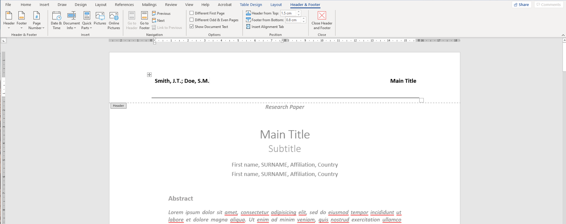
Figure 1. Editing the Headline. Source: ISOCARP.

2.2. Use of the paragraphs
Use the existing styles and fonts without changing the setting.
The paragraph styles in the template contain:
- ‘Title’ (Calibri Light, 22pt) and ‘Subtitle’ (Calibri Light, 18pt)
- ‘Abstract’ (Calibri, Italic, 10pt) for abstract text and keywords
- ‘Heading 1’ (Calibri, Bold, 14pt) or ‘Heading 2’ (Calibri, Bold, 12pt) for the title of paragraphs and subparagraphs
- ‘Normal’ for major text (Calibri, 10,5pt)
- ‘Reference Paragraph’ for the list of references (Calibri, 10,5pt)
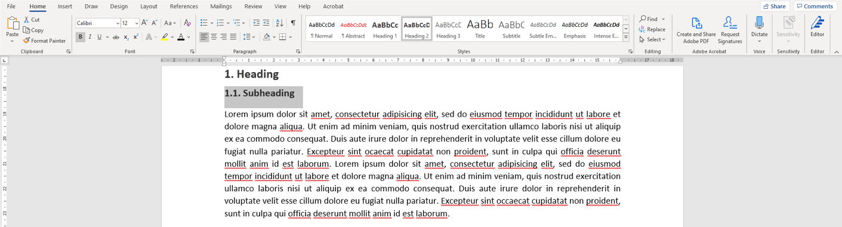
Figure 2. Use of the paragraphs. Source: ISOCARP.

2.3. Placing the figures
Remember to give a title or a short description to images, figures, and tables included in the text. Keep in mind also adding the source of all data and figures.
Use ‘Insert Caption’ tool available in the menu after right mouse click.
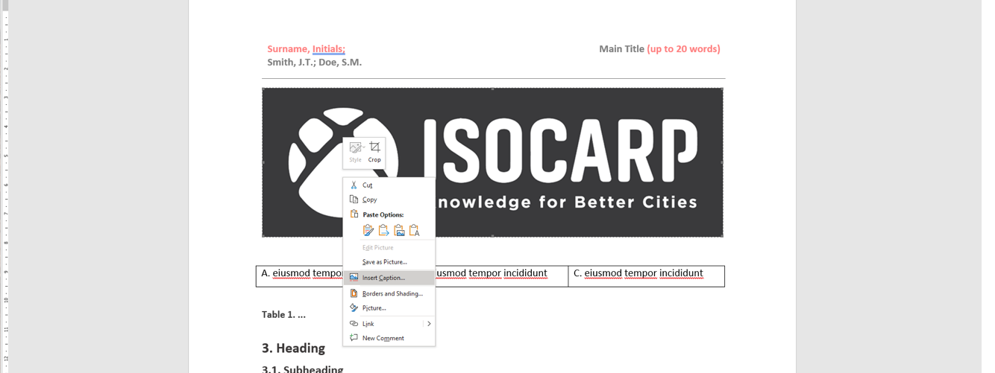
Figure 3. How to use the command ‘Insert Caption’. Source: ISOCARP.

3. Heading

3.1. Subheading
Lorem ipsum dolor sit amet, consectetur adipisicing elit, sed do eiusmod tempor incididunt ut labore et dolore magna aliqua. Ut enim ad minim veniam, quis nostrud exercitation ullamco laboris nisi ut aliquip ex ea commodo consequat. Duis aute irure dolor in reprehenderit in voluptate velit esse cillum dolore eu fugiat nulla pariatur.

4. References
Please use the “Harvard style” of references (in Mendeley - Harvard Reference style 1). Use approximately 20 to 60 references.
Book: Author surname(s), initials(s), (Year published) Title. Edition. Place of publication: Publisher.
Mitchell, J.A. and Thomson, M. (2017) A guide to citation. 3rd edn. London: London Publishings.
Edited Book: Editor surname(s), initial(s). (eds.) (Year Published). Title. Edition. Place of publication: publisher.
William, S.T. (eds.) (2015) Referencing: a guide to citation rules. New York: My Publisher
Chapter in an Edited Book: Editor surname(s), initial(s). (Year Published). ‘Title of chapter’ in editor(s) surname(s), initials(s) (eds.) Title of book. Edition. Place of publication: publisher, page numbers.
Troy B.N. (2015) ‘Harvard citation rules’ in Williams, S.T. (ed.) A guide to citation rules. New York: NY Publishers, pp. 34-89.
E-Book: Author surname(s), initial(s). (Year Published). Title. Edition. E-book format [e-book reader]. Available at URL or DOI (Accessed: day month year)
Mitchell, J.A., Thomson, M. and Coyne, R.P. (2017) A guide to citation. E-book library [online]. Available at: https://www.mendeley.com/reference-management/reference-manager (Accessed: 10 September 2016)
Journal Article: Author surname(s), initial(s). (Year) ‘Title of article’, Title of journal, volume (issue), page numbers.
Mitchell, J.A. ‘How citation changed the research world’, The Mendeley, 62(9), p70-81.
Online Journal: Author surname(s), initial(s). (Year) ‘Title of article’, Title of journal, volume (issue) [online]. Available at: URL or DOI (Accessed: day month year)
Mitchell, J.A. ‘How citation changed the research world’, The Mendeley, 62(9) [online]. Available at: https://www.mendeley.com/reference-management/reference-manager (Accessed: 15 November 2016)
Newspaper Article: Author surname(s), initial(s). (Year) ‘Article Title’, Newspaper Title (edition), day month, page number(s).
Mitchell, J.A. (2017) ‘Changes to citation formats shake the research world’, The Mendeley Telegraph (Weekend edition), 6 July, pp.9-12.
Online Newspaper: Author surname(s), initial(s). (Year) ‘Article Title’, Newspaper Title (edition), day month [online]. Available at: URL or DOI (Accessed: day month year)

