An interesting title - A4 paper size, one column format
Jane Doe¹, Mario C. Rossi^{2*}, and Pedro J. Perez Gómez^{1,2}

1 Department of Geoscience and Engineering, Delft University of Technology, Delft, The Netherlands
2 Dipartimento di Ingegneria Civile e Ambientale, Politecnico di Milano, Milano, Italy

Page layout
This template includes all styles for formatting an extended abstract for the Soft Soils 2026 conference in Delft. Please read and follow the instructions carefully.
The document must be three to four A4 pages (210 x 297 mm) long. Adjust the margins to those shown in Table 1. Please check the conference website (Soft Soils 2026) for all important dates. Please use the predefined MS Word styles of this template for all formatting purposes and avoid using additional formatting of your text.
Table 1. Setting Word’s margins.
Margin | mm
Top | 25
Bottom | 20
Left | 20
Right | 20

Formatting the title, authors and affiliations
Please choose a title for your extended abstract that has a maximum length of two lines. The title is set in bold 16-point Arial, justified. The first letter of the title should be capitalised with the rest in lower case except proper nouns, and acronyms.
The style for the names is First Names, typed in italic 10-point Times, then Last Name, typed in 10-point Times, with a comma after all except the last author, which is separated by comma + “and”. Do not use academic titles. The corresponding author should be indicated by an asterisk.
Affiliations of authors should be typed in 9-point Times. They should be preceded by a numerical superscript corresponding to the same superscript after the name of the author concerned. Please ensure that affiliations are as full and complete as possible and include the country.

Formatting the text
The structure of the contribution is open, but a short Introduction and Conclusion section are mandatory. The text of your paper should be formatted as follows:
- 10-point Times, Times Roman or Times New Roman.
- The text should be set to single line spacing.
- Paragraphs should be justified.
- The first paragraph after a section or subsection should not be indented; subsequent paragraphs should be indented by 5 mm. For convenience, make use of the styles provided in this template.
Due to the limited extension of the document, try to avoid subheadings. Keep headings concise and avoid multi-line headings. Where the author wishes to divide the paper into sections, the formatting shown in Table 2 should be used.

Table 2. Formatting sections, subsections and subsubsections.
 | Font | Spacing | numbering
Section | 12-point Arial bold | 6 mm before 3 mm after | 1, 2, 3, etc.
subsection | 10-point Arial bold | 6 mm before 3 mm after | 1.1, 1.2, 1.3, etc.
When needed, use bullet lists with style “List Bullet”:
- This is a list item.
- This is another list item.
Alternatively, use a numbered list with style “List Number”:
- This is a numbered list item.
- This is another numbered list item.

Figures and tables
Figures and tables, as originals of good quality and well contrasted, are to be in their final form, ready for reproduction, pasted in the appropriate place in the text. Try to ensure that the size of the text in your figures is approximately the same size as the main text (10 point). Try to ensure that lines are no thinner than 0.25 point. Before saving the MS-Word document after including the first figure, ensure that the default resolution is set to “high fidelity” and that the option “do not compress images in files” is active (see “File” “Options” “Advanced” “Image and Size Quality”).
Captions should be typed in 9-point Times. They should be centred above the tables and centred beneath the figures. Keep captions as short as possible and end them with a full stop. If you have multiple figures, please reference them with lowercase alphabetical characters (a,b,c, …) and indicate them in the caption. In order to facilitate the document layout, we suggest placing the figures inside a table together with their caption.
We suggest using the following typologies of figure layouts:
- Single figure in a row, as in Figure 1.
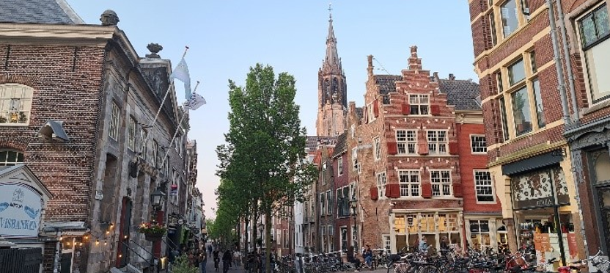
Figure 1. View of the old city centre of Delft, The Netherlands.
- Two figures in a row as subfigures, as in Figure 2a and Figure 2b.
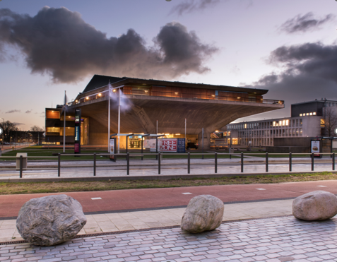 | 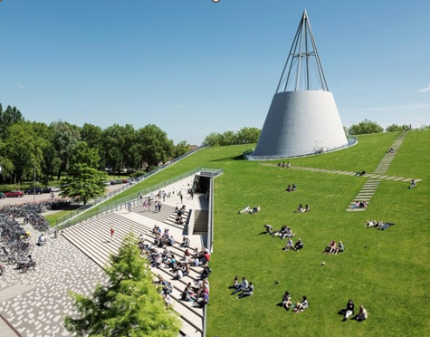
(a) | (b)
Figure 2. TU Delft University campus: Aula congress centre (a), and library (b).
- Two figures in a row as single figures, as in Figure 3 and Figure 4.
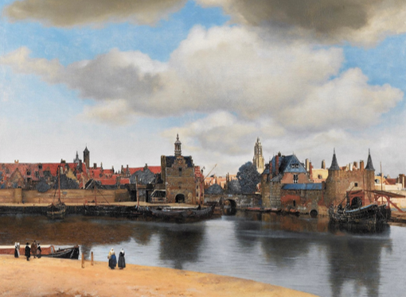 | 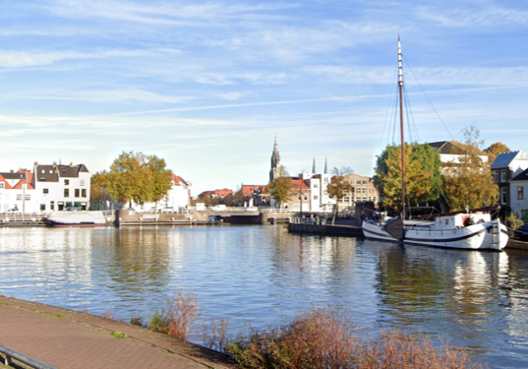
Figure 3. The "View of Delft by J. Vermeer, 1661. | Figure 4. Modern view of Delft.
Please use a font size of 10pts for the table. Keep the formatting minimal with only horizontal lines at the top and the bottom of the table, and an additional line separating the header of the entries. Table 1 shows an example of a table.
The paragraph after a table is formatted as “Paragraph” and has an indent. Table captions are placed above the table with a font of 9 pts and should be referenced in the text with a cross-reference with Times New Roman.

Equations and mathematics
We encourage you to use the MS Word equation editor and number your equations consecutively on the right-hand side. The example in Equation (1) is defined within a table with no borders. The equation is placed in the left column, and the automatic numbering is placed into the right.
The easiest way to create your own equations is to copy the whole table, including the example equation, and to modify it as needed. The following formatting rules are suggested (SI Brochure - BIPM), in general:

- Only variables should be italicised.
- Units, functions, numbers, etc., are always upright.
- Thin space between number and unit(s).
- Use bold for vectors and matrices.
An example of equation format can be seen in Equation (1) and Equation (2).
 | $$dσ^{'}=dσ-{dp}_{w}I$$ | (1)
 | $$A=π r^{2}$$ | (2)
Equations are followed by a paragraph with indentation.

Quoting references
References should be cited in the text by placing sequential numbers in brackets (for example, [1], [2, 5, 7], [8-10]). They should be numbered in the order in which they are cited. A complete reference should provide enough information to locate the article. References to printed journal articles should typically contain:
• The authors, in the form: initials of the first names followed by last name (only the first letter capitalised with full stops after the initials),
• The title of the article
• The journal title (abbreviated),
• The volume number (bold type),
• The article number or the page numbers,
• The year of publication (in brackets),
• The DOI number (digital object identifier)

Authors should use the forms shown in Table 3 in the final reference list.

Table 3. Font styles for a reference.
Element | Style
Authors | Reference Body  (Initials followed by last name)
Article title | Reference Body
Journal title | Reference Body  (Abbreviated)
Book title, Proceedings title | Reference Body - Book/Proceedings title
Volume number | Reference Volume Bold
Page number | Reference Body
Year | Reference Body  (In brackets)
DOI | Reference Body + Hyperlink

You can formally recognise any support provided outside of the authors contributions. This includes assistance with administrative and technical tasks, financial contributions, or donations of materials used for experiments. The Acknowledgements, Fundings, Data availability statement, Author contribution statement, should be typed before the references in 9-point Times, without title.

References
Here are some examples:

- A. Nicolas, J.-L. Barrat, J. Rottler, Effects of inertia on the steady-shear rheology of disordered solids. Phys. Rev. Lett. 116, 058303 (2016)
- A. Lohrasebi, T. Koslowski, Modeling water purification by an aquaporin-inspired graphene-based nano-channel. J. Mol. Model. 25, 280 (2019). https://doi.org/10.1007/s00894-019-4160-y
- M. Ben Rabha, M.F. Boujmil, M. Saadoun, B. Bessaïs, Eur. Phys. J. Appl. Phys. (to be published)
- J. Couturier, Y.H. Abou and E. Grolleau, Element of nuclear safety, (EDP Sciences, Les Ulis, 2019)
- M.N. Ozisik, Radiative transfer and interactions with conduction and convection (John Wiley and Sons, New York, 1973)
- J. Rhodes, K. Smith, D. Lee, CASMO-5 development and applications, in Proceedings of the PHYSOR-2006 conference, ANS Topical Meeting on Reactor Physics, Vancouver, BC, Canada, September 10-14, September 10-14 (2006), B144
- S. Azzaoui, SCALE-6 fuel depletion analyses: Application to the ARIANE program, Master Thesis, SCK-CEN, Belgium, 2010
- K. Ambrožič, L. Snoj, Characterization of gamma field in the JSI TRIGA reactor, Ph.D. thesis, University of Ljubljana, Faculty of Mathematics and Physics (2020)

