Teaching Moment
Demonstrating Supply Chain Tenets in a Principles of Marketing course: Legos and Structures For Sale
C. Michelle Sullivan, East Tennessee State University, USA

Experiential Exercise

In this Experiential Exercise, students in the 80 minute course are broken into groups to represent the supply chain. The first group is assigned the role of supplier and are given a box of legos with many mixed pieced and colors. The next groups are assigned the role of manufacturers and are given printed cash of $1000 in small bills to purchase from suppliers materials to build a structure or structures to sale to the public. These groups must decide how to spend their dollars and what kinds of features and structures they want to manufacture. The final groups are given printed money of $5000 in larger bills to be able to purchase any of the desired manufactured structures available for sale. One group is also designated as a wholesaler group. This group is assigned the role of purchasing unwanted or unsold items from manufactures to redesign, rebuild, repackage, etc.

Each group is taken out of the room by the instructor and given a brief explanation of their role in the simulation and any needed materials for their assigned roles.

Suppliers – All Legos, paper and pens to calucate profit. They can assign a $ value to each block or sets of blocks for a bundle price if they so choose. The goal is to make a profit and clear all inventory by the end of class.

Manufacturers – Money, purchase materials, and instructions on their role – i.e., what are you going to build that customers will want to purchase? Think about your costs, features, design elements, market research, etc? Some of the groups forget to consider market research and realize no one will purchase their products at the end.

Wholesalers- This group is given money to purchase structures directly from the manufacturers and then have the option to redesign, redevelop, etc for resale. They can purchase additional materials from the suppliers if they desire. They can also purcashe more than one structure and combine features, etc.

Consumers – This group watches the other groups as the go through the process. They are available for other groups to conduct market research during the process. When manuyfacturers or wholesalers are ready to sell, they are available for the sales pictches and product demonstrations. They can negotiate additional features, lower costs, etc. They can also choose not to purchase. Consumers can also purchase material from suppliers themselves and build what they desire.

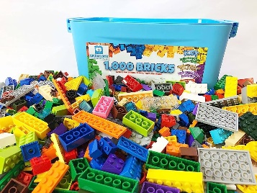
At the end of class, all teams are brought together to discuss and evaluate the process of the supply chain. This activity is very highly rated in teaching evaluations for demonstrating the role and importance of the supply chain as it relates to the marketing function of business. If provides many “ah-ha” moments for students to connect the core concepts to real world applications.



