Research Paper

Main Title
  - Subtitle
First name SURNAME, Affiliation, Country

Abstract
The abstract should give a brief overview of the article content. It is afterwards published as a manuscript synopsis, so please be careful when writing this short piece of text – the readers might be either encouraged to dig further into the text or deterred by the quality of this short introductory note. Please include the main findings, briefly summarised and preceded by the short introductory note that explains the research context and significance. It is not recommended to use references in the abstract. It is recommended to include 300-600 words in this part. Lorem ipsum dolor sit amet, consectetur adipisicing elit, sed do eiusmod tempor incididunt ut labore et dolore magna aliqua. Ut enim ad minim veniam, quis nostrud exercitation ullamco laboris nisi ut aliquip ex ea commodo consequat. Duis aute irure dolor in reprehenderit in voluptate velit esse cillum dolore eu fugiat nulla pariatur. Excepteur sint ocaecat cupidatat non proident, sunt in culpa qui officia deserunt mollit anim id est laborum. Lorem ipsum dolor sit amet, consectetur adipisicing elit, sed do eiusmod tempor incididunt ut labore. Lorem ipsum dolor sit amet, consectetur adipisicing elit, sed do eiusmod tempor incididunt ut labore.

Keywords
Keyword, Keyword, Keyword, Keyword (3 to 6 keywords)

1. Introduction

A research paper is an academic contribution to a specific field, discipline, or topic. It should be between 3,000 and 5,000 words, including the manuscript and references. The text should be accompanied by tables and figures to enhance clarity. Photographs illustrating a case study context may also be included. When applicable, please add acknowledgements and information about research funding.

The manuscript should have a clear focus and a well-structured organization. Following the introduction, which should end with a brief paragraph outlining the paper’s structure, the background research should be presented. This includes a concise overview of the scholarly literature and/or applied research relevant to the paper’s subject. Authors should clearly explain how their research question contributes to cities in action, how it interprets or contributes to the pathway to quality of life and resilience, and how it explains, tackles, or expands the track as submitted. The methodology applied should then be explicitly described. After presenting the case study (if applicable), the core part of the paper should present the research results. Subsequent sections should include a discussion of the research outcomes, concluding remarks, and, optionally, plans for future investigations.

2. Methodology
Describe research approach, theoretical framework used, data collection and data analysis methods.

3. Discussion (replace by your heading)

3.1. Filling the template (replace by your subheading)
Please use the styles defined in this template for the content formatting. Please remember that these notes in red font colour are to be deleted during submission.
You must use the ISOCARP templates without altering margins, paragraph styles or fonts. Please fill in your name and title in the Header by double clicking on it. Do not add or modify anything in the Footer and margin settings.
Above ‘Main Title’, leave only the category of your paper: Research
Please limit the main title up to 20 words.
Please fill in the authors’ names as in the example below.
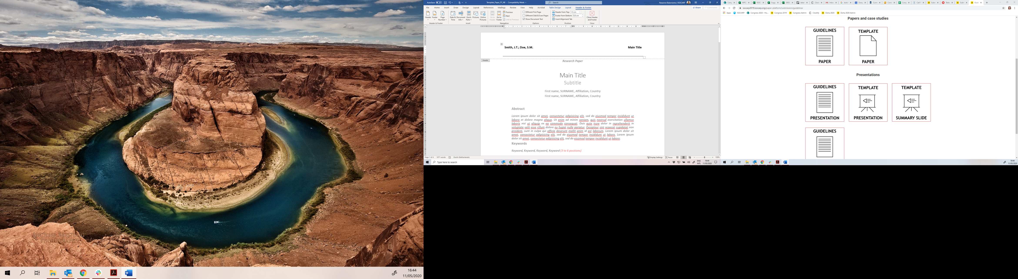
Figure 1. Editing the Headline. Source: ISOCARP.

3.2. Use of the paragraphs (replace by your subheading)
Use the existing styles and fonts without changing the setting.
The paragraph styles in the template contain:
- ‘Title’ (Calibri Light, 22pt) and ‘Subtitle’ (Calibri Light, 18pt)
- ‘Abstract’ (Calibri, Italic, 10pt) for abstract text and keywords
- ‘Heading 1’ (Calibri, Bold, 14pt) or ‘Heading 2’ (Calibri, Bold, 12pt) for the title of paragraphs and subparagraphs
- ‘Normal’ for major text (Calibri, 10,5pt)
- ‘Reference Paragraph’ for the list of references (Calibri, 10,5pt)
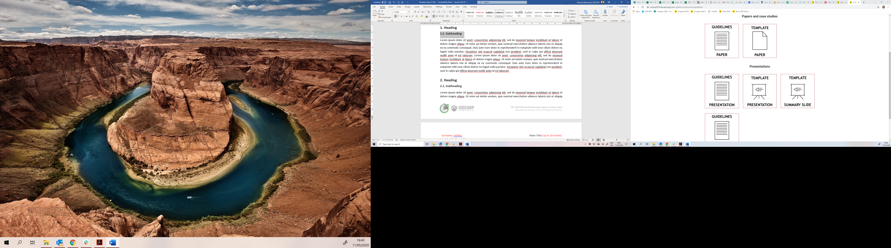
Figure 2. Use of the paragraphs. Source: ISOCARP.

3.3. Placing the figures (replace by your subheading)
Remember to give a title or a short description to images, figures, and tables included in the text. Keep in mind also adding the source of all data and figures.
Use ‘Insert Caption’ tool available in the menu after right mouse click.
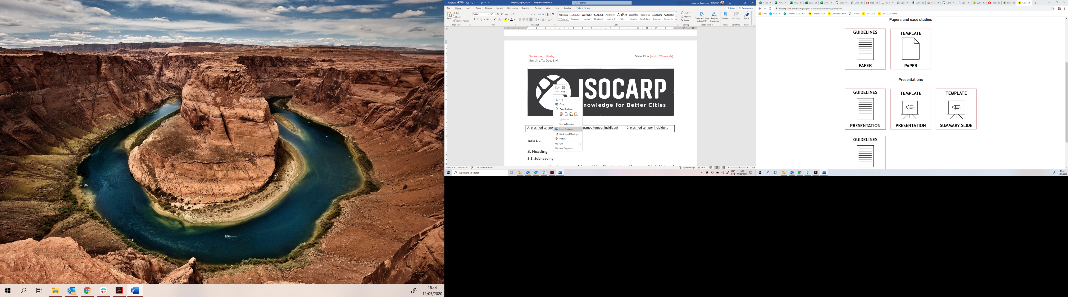
Figure 3. How to use the command ‘Insert Caption’. Source: ISOCARP.

4. Conclusion
Summarise and provide your main findings, contributions to theory and practice, and lessons learned. If possible, describe whether the study/project can be repeated or scaled up to a larger number of cases and for broader use.

5. References
Please use the “Harvard style” of references (in Mendeley - Harvard Reference style 1). Use approximately 20 to 60 references.
Book: Author surname(s), initials(s), (Year published) Title. Edition. Place of publication: Publisher.
Mitchell, J.A. and Thomson, M. (2017) A guide to citation. 3rd edn. London: London Publishings.
Edited Book: Editor surname(s), initial(s). (eds.) (Year Published). Title. Edition. Place of publication: publisher.
William, S.T. (eds.) (2015) Referencing: a guide to citation rules. New York: My Publisher
Chapter in an Edited Book: Editor surname(s), initial(s). (Year Published). ‘Title of chapter’ in editor(s) surname(s), initials(s) (eds.) Title of book. Edition. Place of publication: publisher, page numbers.
Troy B.N. (2015) ‘Harvard citation rules’ in Williams, S.T. (ed.) A guide to citation rules. New York: NY Publishers, pp. 34-89.
E-Book: Author surname(s), initial(s). (Year Published). Title. Edition. E-book format [e-book reader]. Available at URL or DOI (Accessed: day month year)
Mitchell, J.A., Thomson, M. and Coyne, R.P. (2017) A guide to citation. E-book library [online]. Available at: https://www.mendeley.com/reference-management/reference-manager (Accessed: 10 September 2016)
Journal Article: Author surname(s), initial(s). (Year) ‘Title of article’, Title of journal, volume (issue), page numbers.
Mitchell, J.A. ‘How citation changed the research world’, The Mendeley, 62(9), p70-81.
Online Journal: Author surname(s), initial(s). (Year) ‘Title of article’, Title of journal, volume (issue) [online]. Available at: URL or DOI (Accessed: day month year)
Mitchell, J.A. ‘How citation changed the research world’, The Mendeley, 62(9) [online]. Available at: https://www.mendeley.com/reference-management/reference-manager (Accessed: 15 November 2016)
Newspaper Article: Author surname(s), initial(s). (Year) ‘Article Title’, Newspaper Title (edition), day month, page number(s).
Mitchell, J.A. (2017) ‘Changes to citation formats shake the research world’, The Mendeley Telegraph (Weekend edition), 6 July, pp.9-12.
Online Newspaper: Author surname(s), initial(s). (Year) ‘Article Title’, Newspaper Title (edition), day month [online]. Available at: URL or DOI (Accessed: day month year)
OpenAI. (2025) ChatGPT (GPT-4) response to query on urban planning methodology. OpenAI [online]. Available at: https://chat.openai.com/ (Accessed: 10 September 2025).
AI Tool (Version/Date). Title or description of the output. Publisher/Platform. Available at: URL (Accessed: day month year).

