Banks Climate Stress Testing Based on Energy Sectors
Tao Ling^{a, b}, Bing-Yue Liu^{a, b}, Zi-Xin Wang^{a, b}, Ying Fan^{a, b*}
a School of Economics and Management, Beihang University, Beijing 100191, China
b MOE Laboratory for Low-carbon Intelligent Governance (LLIG), Beihang University, Beijing 100191, China
Corresponding author: yfan1123@buaa.edu.cn

To meet climate targets, production shifts in climate policy–relevant sectors (hereafter, CPRS) can weaken the credit quality of banks’ loan portfolios, elevate bank-level risk, and ultimately amplify systemic risk in the banking system. Quantifying such transition-risk exposure therefore requires an integrated climate stress-testing framework that captures both balance-sheet impacts and network-based contagion.
Fig. 1 Climate stress test framework
This paper investigates China’s 20 systemically important banks (SIBs) and estimates the direct and indirect losses arising from climate transition risk using industrial loan exposures and interbank lending relationships. We combine AR6-based scenario information with asset valuation approaches to translate sectoral transition shocks into bank losses, and apply network analysis to assess how distress can propagate through interbank linkages. This design enables a consistent comparison of banks’ risk profiles across Representative Concentration Pathway (RCP) scenarios while distinguishing direct risks from amplification effects (indirect) driven by the interbank network.
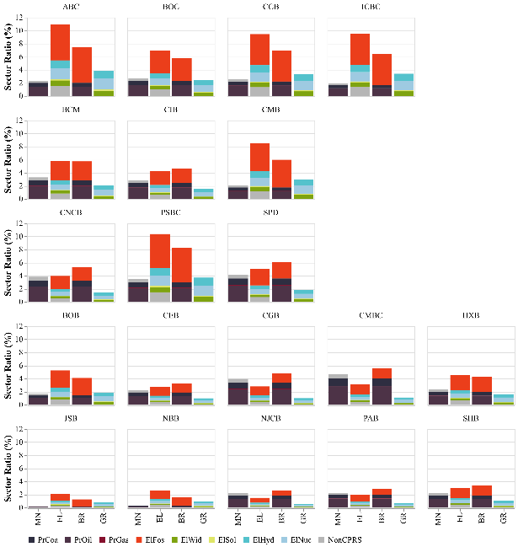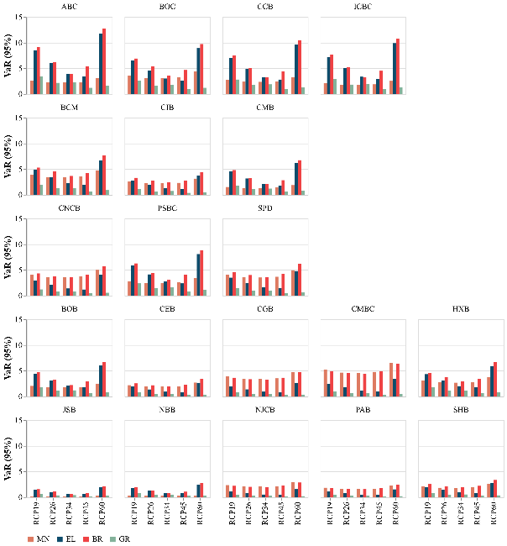
Fig. 2 The sector distribution in industrial loans of SIBs and their climate VaR (95%)
Empirically, the electricity production (EL) sector is identified as the most exposed to transition risk. Carbon-intensive (brown) lending exhibits a higher average equity impairment ratio than clean (green) lending (4.58% versus 1.77%). Across all SIBs and RCP scenarios, the mean climate Value-at-Risk (Climate VaR) is 9.19%, with risk peaking under the RCP6.0 scenario (12.36% on average). Moreover, indirect losses transmitted through the interbank network exceed direct losses by roughly a factor of three on average, underscoring the importance of contagion channels.
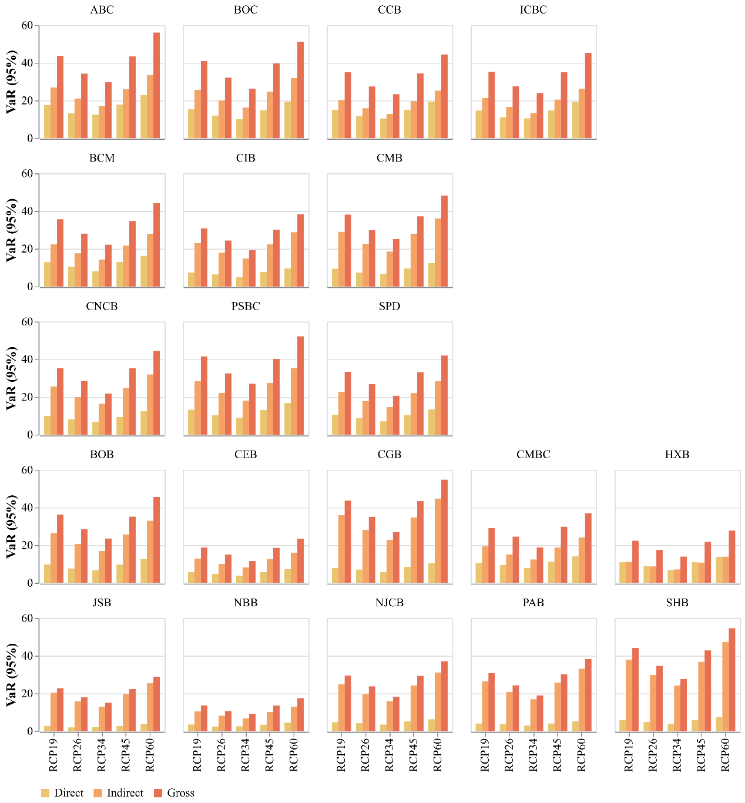
Fig. 3 Climate direct and indirect VaR (95%) across SIBs and RCPs
These results imply that regulators should strengthen differentiated supervision for higher-ranked SIBs and enhance monitoring of exposures to highly vulnerable sectors, while banks should proactively rebalance loan portfolios toward lower-transition-risk activities. Finally, the analysis indicates that more stringent climate targets can reduce transition risks relative to more lenient pathways.

Keywords: systemically important banks, climate transition, energy sectors, climate stress testing, interbank network

